MC EDT Web API Project

## About DoctorCare

DoctorCare is a group of clinicians and business professionals dedicated to improving healthcare in Ontario. We are the only provider focused exclusively on helping Primary Care Physicians enhance patient care, run better businesses – and improve their own quality of life.

Our services focus on enhancing chronic disease management, billing and technology, and clinic workflow, helping 1,200+ family doctors improve the lives of more than 1.5 million patients.

Ontarians get tremendous benefits from our healthcare system. But inefficiencies, inconsistencies and lost opportunities can limit the quality of care they receive. This is particularly evident in primary care practices, where doctors are caring for complex patient populations and simply don’t have the time or resources to focus on maximizing efficiency.

The founders of DoctorCare, Paulo Gomes and Adam Hutton, both with extensive experience providing systems for the healthcare industry, realized that the solution was simple. Doctors needed expert support to help them run their practices – support they simply didn’t have the resources for in-house. So in 2010, they founded a service model with a clear approach: patients count on doctors – so doctors need someone to count on too. That’s DoctorCare: a solution provider to help doctors cut wait times, improve the delivery of preventive care, better manage chronic disease programs – and help manage OHIP fee schedules and add billing efficiencies.

## Project Motivation

DoctorCare’s [Practice Care Product](https://www.doctorcare.ca/solutions/practice-care-fho-program/) is an analytic product that provides primary care practitioners with insights about opportunities to improve their medical practice and business. DoctorCare has developed technology product (Practice Care) that translates a set of data into actionable insights. In simple terms:

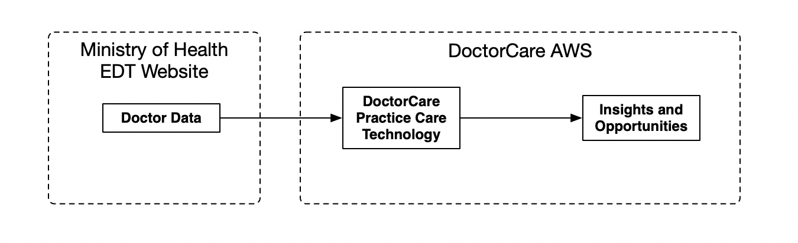

Currently, the Doctor Data input to the product is acquired by downloading files from the ministry of health’s website using a web scraping technology. The data is then stored in the Practice Care platform (hosted on Amazon Web Services - AWS) at which point it is analyzed with outputs stored in the same Practice Care platform.

DoctorCare would like to replace the web scraping technique for acquiring the Doctor Data and instead, acquire the data from the Ministry of Health’s proper web service API - MC EDT Web service. This migration from web scraping to api is required as:

* the web scraping is prone to errors
* The web scraping is not efficient
* The web scraping is not officially supported by the Ministry of Health for the purposes of automation.

## Project Goals

1. Develop python library capable of connecting to ministry of health’s MC EDT API and acquiring the Doctor Data from the MC EDT Web Service.
2. Pass Ministry of Health certification. The Ministry of Health conducts certification for all applications that would like to consume from their MC EDT API. Passing this certification is a required goal.

## In Scope

1. Develop python library capable of passing ministry of healths certification tests.
2. Develop supporting tooling (as required) in order to pass the ministry of health’s certification tests.
3. Project management of entire development and testing process.
4. Support any and all testing as required by the ministry of health.

## Out of Scope

1. Integration of final python library into Practice Care product.
2. Conformance testing registration (DoctorCare to register and manage ministry of health registration needs).

## Useful Documentation

See “Documentation” folder for various documents on the MC EDT service.

## Milestones

1. DoctorCare officially registered with Ministry of Health’s conformance testing program.
2. Python library API design complete
3. Python library passes internal conformance testing.
4. Python library passes Ministry of Health conformance testing.